Proceedings of the 20th International Ship and Offshore Structures Congress (ISSC 2018) – M.L. Kaminski and P. Rigo (Eds.)
© 2018 The authors and IOS Press.
This article is published online with Open Access by IOS Press and distributed under the terms of the Creative Commons Attribution Non-Commercial License 4.0 (CC BY-NC 4.0).
doi <...>

COMMITTEE No
NAME

COMMITTEE MANDATE

Mandate Mandate Mandate Mandate Mandate Mandate Mandate Mandate Mandate Mandate Mandate Mandate Mandate Mandate Mandate Mandate Mandate Mandate Mandate Mandate Mandate Mandate Mandate Mandate Mandate Mandate Mandate Mandate Mandate Mandate Mandate Mandate Mandate Mandate Mandate Mandate Mandate Mandate Mandate Mandate Mandate Mandate Mandate Mandate

CONTRIBUTERS
Official Discusser xyz

Floor Discussers xyz
xyz
xyz
xyz
xyz
xyz

Reply by Committee
Chairman: xyz
xyz
xyz
xyz
xyz
xyz
xyz
xyz
xyz

Contents
1. DISCUSSION 3
1.1 Official Discussion by xyz 3
1.1.1 Introduction 3
1.1.2 Remarks 3
1.2 Floor and Written Discussions 3
1.2.1 Xyz1 3
1.2.2 Xyz2 3
1.2.3 Xyz3 3
2. REPLY BY COMMITTEE 4
2.1 Reply to Official Discusser 4
2.1.1 Equations 4
2.2 Reply to Written and Floor Discussion 4
REFERENCES 4

DISCUSSION
Major sections on 1st Level: Times New Roman, 12 pt, uppercase letters, 6pt space above and below section headline.

Official Discussion by xyz

Introduction
The font to be used for standard text is: Times New Roman, 12 pt, normal, justified, paragraphs separated by 6 pt. The type area is:
- 16 cm wide
- 26 cm high.
This information at the same time shows how an itemization should be written: each item should be separated from others above and below with no extra vertical space in between. The list of item starts with a new paragraph (6pt vertical space above), the following paragraph below the list has a normal distance of 6pt.

Remarks
Do not use italic, bold or underlined font for highlighting in the standard text. Note that we will use your Word-file as a base to produce the final layout of the proceedings.

Floor and Written Discussions

Xyz1
The Harvard style should be used for references in the text. Here some examples: “Author (2011) has carried out a comparative study on the analytical methods being used ……” If referring to papers of maximum two authors both are named like “Author_1 and Author_2 (2010a, 2010b)” which refers to two papers of the two authors which were both publishes in 2010. If referring to papers with more than two authors only the first is named with an added et al. like: “Author_3 et al. (2009) presented the first …” Note that references dating back past the previous ISSC in 2009 should have been discussed in the last committee report.
Subsection title on 2nd Level: Times New Roman, 12 pt, bold+italic, 6pt space above and below subsection headline. Text Text Text Text Text Text Text Text Text Text Text Text Text Text Text Text Text Text Text Text Text Text Text Text Text

Xyz2
Subsubsection title on 3rd Level: Times New Roman, 12 pt, italic, 6pt space above and below section subsubsection headline. Do not use a document structure with more than three section levels.

Xyz3
Figures. Avoid using illustrations taken from the Web. The resolution of images intended for viewing on a screen is not sufficient for the printed version of the book. The preferred resolution is 300 DPI.
If you are incorporating screen captures, try to use a good-quality screen capture tool so that text remains legible.
Colour illustrations will be printed in black & white, but retained in full colour in the online (ebook) edition.
Text Text Text Text Text Text Text Text Text Text Text Text Text Text Text Text Text Text Text Text Text Text Text Text Text Text Text Text Text Text Text Text Text Text Text Text Text Text Text Text Text Text Text Text Text Text Text Text Text Text Text Text Text Text Text Text Text Text Text Text Text Text Text Text Text Text Text Text Text Text Text Text Text Text Text Text Text Text Text Text Text Text Text Text Text Text Text Text Text Text Text Text Text Text Text Text
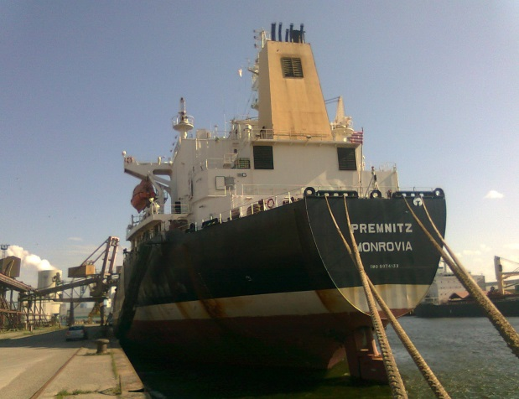
Figure. 1: Figure caption to be placed below the figure

Text Text Text Text Text Text Text Text Text Text Text Text Text Text Text Text Text Text Text Text Text Text Text Text Text Text Text Text Text Text Text Text Text Text Text Text Text Text Text Text Text Text Text Text Text Text Text Text Text Text Text Text
Tabel 1: Table caption to be placed above the table

REPLY BY COMMITTEE

Reply to Official Discusser

Equations
Equations should be set centred on an extra line. Each equation should have its own equation number on the same line right justified as shown below:
A = B ⋅ C(1) (1)
Under references below, some formatting examples are shown.

Reply to Written and Floor Discussion

REFERENCES
Abels, W. (2007) Integration of Software Packages with Different Programming Paradigms, Exemplified by a Ship Model Generating Tool, Compit’2007, Cortona, Italy.
Alonso, F. et al. (2007 a) Collaborative Design - A Practical Approach based on the Use of Replicated Databases for Concurrent Design, Compit’2007, Cortona, Italy.

